Response to:

Fairness & Well-being Commission - Call for Evidence
The Get Doncaster Moving (GDM) Team welcomes the opportunity to support the Commission’s call for evidence. We have been working formally alongside Sport England for almost five years, developing place-based whole systems approaches to achieve our vision of:

‘Healthy and vibrant communities through movement, physical activity and sport’

Inclusivity, reducing inequalities and supporting those most in need is one of the guiding principles of the GDM team’s work.

Our original GDM strategy in 2018 was one of the first to recognise the importance of a place-based whole system approach, supported by a ‘test and learn’ way of working. In this submission, we provide an insight into what we learned from place-based, whole system working to tackle inequalities in physical activity that could be applied to other service areas/projects.

The GDM Team has a rich amount of insight and learning to help understand how these strategic challenges impact quality of life in communities – and then co-create long-term, sustainable change with community. This growing repository is published is on the GDM Website.

This submission sets out a number of key parts of this data, insight and learning which may be of particular interest to the Commission.

Contents
Introducing the ‘Get Doncaster Moving’ Partnership 3
SECTION 1 5
Developing Our Evidence Base 5
Understanding the Challenges 5
Considering residents’ Capability, Opportunity & Motivation 8
SECTION 2 9
Place-based, whole-system working 9
Community-centred approach 9
Considering the whole system 9
Nesting projects within the place and wider system 10
Testing & Learning 10
SECTION 3 11
Tackling Inequalities in Action - Future Parks Programme 11
Listening to Residents 11
Co-producing Improvements 12
Reality Check 13
LTA Parks Tennis Project 13
Demonstrating the value of place-based working 17
SECTION 4 18
Ten suggestions for tackling inequalities 18
SECTION 5 19
Our Asks – To help tackle inequalities in physical activity 19

Introducing the ‘Get Doncaster Moving’ Partnership

Get Doncaster Moving (GDM) is the name of Doncaster's partnership approach to tackling inequalities in physical activity to achieve the vision of:
‘Healthy and vibrant communities through movement, physical activity and sport’

GDM Network
The Network includes any individual, group, business, department or organisation who is committed to taking action and playing their part in supporting residents in Doncaster to access physical activity.
GDM Advisory Board
The Board is made up of senior representatives from the public, private and voluntary sectors and represents and advocates for Get Doncaster Moving at a strategic level.
GDM Team
A small central GDM team, based within Doncaster Council’s Public Health Directorate shares resources and works in partnership with the Well Doncaster and the Wider Determinants teams to provide a central leadership role in creating connections between resident priorities, policy themes and diverse Government objectives.
Local Delivery Pilot
Doncaster is one of 12 Local Delivery Pilots (LDPs) funded by Sport England to achieve a sustained reduction in population physical inactivity levels. The aim is to make physical activity an easier choice for all residents by influencing local policies, places, spaces and people to work coherently as a ‘whole system’.
GDM Strategy
The Strategy has the following priority themes:
- Active environments, parks and facilities
- Active Education
- Workplaces
- Health and Care
- Communications and engagement
- Community led programmes
- Active Travel – walking, wheeling and cycling
- Sport, Dance and Culture for all
- GDM backbone support
- Localities

Principles-driven way of working
The GDM Principles are driven by what we have learnt from communities, what we know about Doncaster and the ethos of 'doing things differently' to test new approaches:
- A whole-of-systems and evidence led approach
- Inclusivity, reducing inequalities and supporting those most in need
- Visible and accountable distributed leadership
- On-going evaluation and impact
- Community and sustainability at the heart of decision-making
- Collaboration and common purpose
GDM see these as fundamental foundations for success.
Communities have told us that they want and need opportunities to last. Our approach focuses capacity and resources on changes that will have a long lasting impact on improving the conditions for residents to be physically active. We strongly believe that unless we stick by our principles, GDM will become a short-lived project or programme which fundamentally doesn't change inactivity in Doncaster.
Tackling Inequalities
We are committed tackling the stubborn inequalities in participation. GDM takes a whole borough approach, with more focused work directed at these groups who need the most support to increase their activity levels:
- The physically inactive (those undertaking less than 30 minutes of physical activity per week).
- Families with children and young people.
- People living in income deprivation including low-income or precarious work.

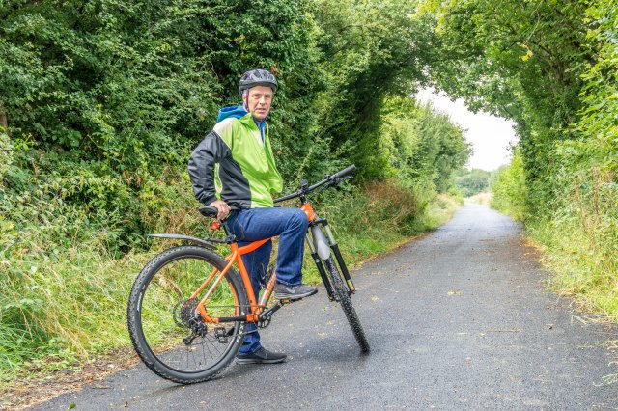

SECTION 1

Developing Our Evidence Base

Understanding the Challenges

The 2019 Index of Multiple Deprivation ranks Doncaster as England’s 41st most deprived area (out of 317). Quality of life varies significantly across the City, as starkly demonstrated by inequality in life expectancy at birth (2018-20). The range in years of life expectancy from the most to the least deprived communities in Doncaster is:
- Male: 10 years
- Female: 8.2 years

Physical activity and sport contributes to healthier people, physically and mentally, often bringing groups of people and communities together, raising aspirations and helping people to achieve them.
However, according to the Active Lives Survey (2021), adults in Doncaster face greater barriers to physical activity than the rest of England. 35% of the adult population in Doncaster are regularly inactive, compared to 27% of adults in England.

Research by the Behavioural Science Consortium (2019) surveyed 1,200 households across 8 of Doncaster’s most deprived communities. The findings identified that inactivity rates in the surveyed communities were almost 60%, compared to the Sport England estimate for Doncaster as a whole of 30% in the year of the survey. There are even inequalities between geographical communities in Doncaster. For example in Balby Bridge, 71% of adults face barriers to regular activity, compared to 40% of adults in Intake. The infographic below compared their findings between the surveyed communities, Doncaster as a whole and in England:

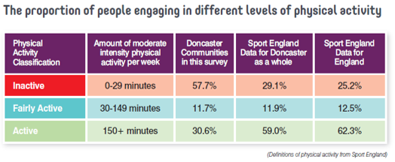

Children and young people
There are similar patterns for children and young people. The Active Lives Children and Young People Survey reports that in England, 45% of children and young people do an hour or more of moderate activity a day, compared to 40% of children in Doncaster (reported by the Doncaster Pupil Lifestyle Survey).

The Behavioural Science Consortium again identified inequalities within Doncaster. For example in Balby Bridge, children were active for an average of 31 minutes per week outside of school time, compared to an average of 207 minutes per week in Intake.

The map below shows the uneven geographical pattern of inactivity across Doncaster, where inactivity is typically higher in the areas that have higher levels of deprivation and face greater health and social inequalities.

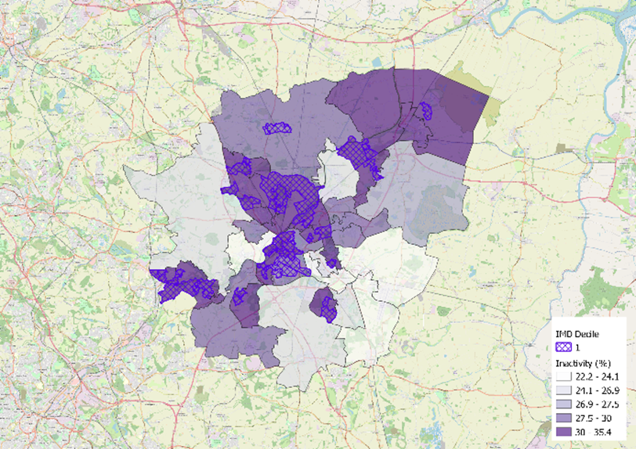
Demographics and inequalities
The Behavioural Science Consortium research found that - ev The tables below show a summary of activity levels by demographics:
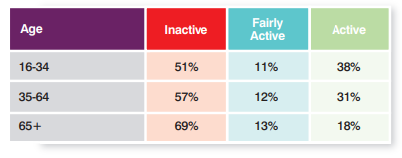

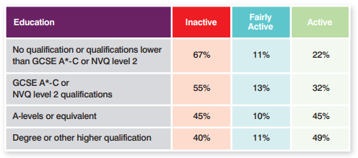

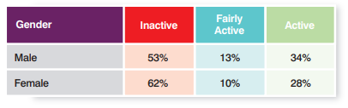

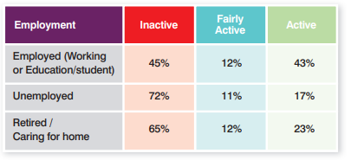

Disability
The table below shows the number of participants that declared having a disability within the
sample, and their physical activity times and the number of participants in each physical
activity classification. The table also shows of those that report having a disability, whether
or not they declare the disability to impact upon their daily activities. 27% of participants (301 households) reported having a physical or mental disability, of which 87% reported that their disability affected their daily activities. The majority of respondents that reported having a disability which affected their daily activity were classified as inactive (78.5%), reporting an average of 57 minutes of moderate intensity activity each week. 196 of the participants reported doing no physical activity each week.
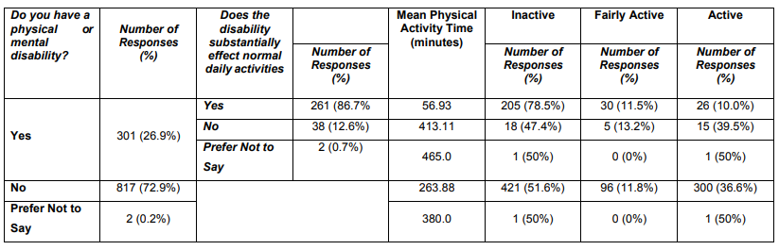

The relationship between inactivity and inequalities
The inequalities associated with physical inactivity are widely evidenced internationally (WHO, 2018) and nationally (Sport England, 2022). An active population is a foundation for a healthy population, contributes significantly to the economy, improves academic attainment and employability and has been shown to reduce crime and anti-social behaviour. More recently, through active travel interventions, the benefits are starting to be evidenced for improving air quality and tackling climate change.

We can therefore make evidence-based assumptions that wider inequalities are contributing to inactivity, which in turn contributes to wider health, social and economic inequalities. The places, policies and spaces that make up the ‘whole system’ we live in, have a large role in shaping our behaviour and the choices we make. Many of the things that stop people from being active are not in their power to change.

Our systems mapping process helps to corroborate these assumptions by highlighting the interconnectedness between barriers and enablers to physical activity.

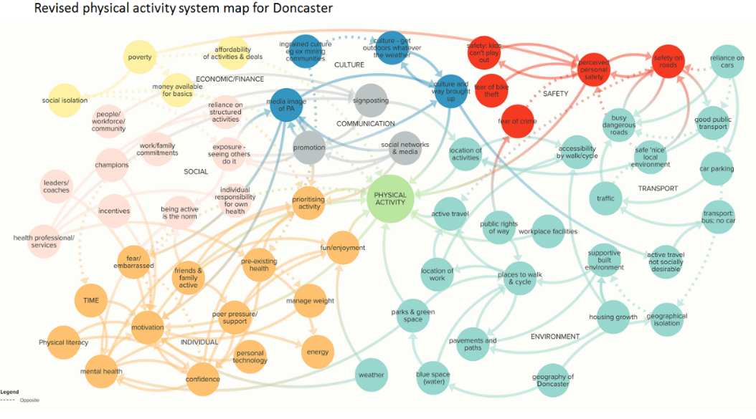

Considering residents’ Capability, Opportunity & Motivation

The Behavioural Science Consortium used the COM-B behaviour change model to help us understand the relationship between capability, opportunity, motivation and physical activity behaviour  Findings from 2019 show the importance of taking a tailored and local approach to tackling physical inactivity, as what may encourage one person to be more active may not work for another when individual capabilities, opportunities and motivations are considered. For some, these characteristics will also intersect making this even more challenging. | 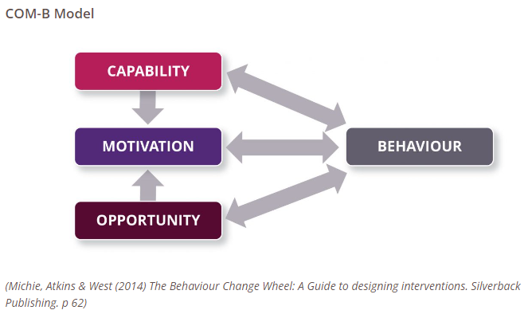

The graph below shows the relationship between the levels of capability, opportunity and motivation and the physical activity behaviour. Active people reported higher levels of capability, opportunity and motivation than those who were less active. This suggests that our approach should consider how to make positive changes across these three factors.
Levels of COM-B differ across communities – therefore we need a bespoke approach for each community.
Active and inactive residents had lower levels of automatic motivation - meaning that people need support to form habits and routines.

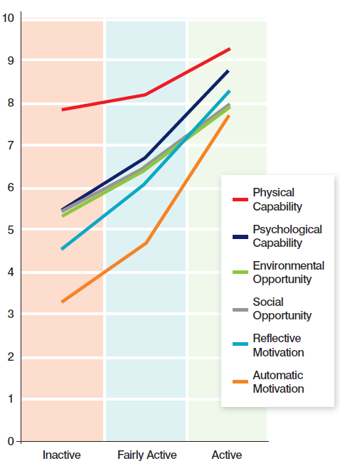

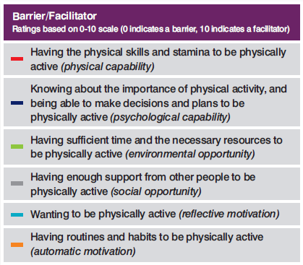

SECTION 2

Place-based, whole-system working

Community-centred approach

GDM, in partnership with Well Doncaster (which was born from the Well North programme) works in communities to understand what matters most to people and then work with them to tackle the opportunities and challenges that can will make a difference to their quality of life.
We are further strengthening and developing community engagement and local intelligence through a programme of Appreciative Inquiries that look at communities individually to understand local needs, barriers, capabilities and opportunities - and to co-develop responses to meet them.
GDM has access to a Residents Panel of 280 Doncaster residents to measure attitudes and perceptions of towards physical activity in order to evidence change. It is fundedy Sport England until March 2025 and managed by CFE Research Ltd (CFE).

Considering the whole system

For GDM, the ‘whole system’ encompasses everyone and everything that both influences physical activity and is influenced by physical activity - across the layers of the system and at individual, community and organisational level. Effective placed-based, whole-system working means:
- Recognising that local communities are best placed to understand what works and to learn by doing.
- A community centred and culturally sensitive approach, which identifies and builds on local strengths and histories and creates the capability to enable residents to see ‘people like me’ being active.
- Recognising that importance of understanding and connecting the whole system that influences people’s motivation and capacity to be physically active (and play sport) - whilst not allowing its complexity to hinder progress.
- Working across the layers of the system and at individual, community and organisational level to influence systemic change.

GDM is on a constant journey to better understand, navigate and connect the whole system in communities. This includes working with Sport England’s National Evaluation and Learning Partnership (NELP) to consider how GDM’s principles can actively influence the way projects are delivered – i.e. the tools, techniques and processes (‘enablers’) that can bring the principles to life to deliver the long-term, sustainable impacts that communities will notice.

Nesting projects within the place and wider system

Working in a place is not necessarily place-based working and place-based working is not necessarily whole system working.  Community centred projects/approaches need to be nested within the place and the wider system.  This is not to invalidate a project that is just place-based – but to extend and sustain the impact, there is a need to influence the wider system. | 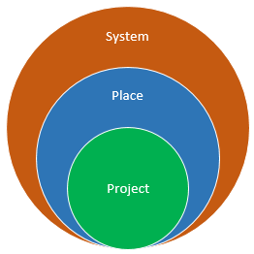

Testing & Learning

Sport England supports all LDPs to take a ‘test and learn’ approach to place-based, whole system, which promotes innovation and an understanding of what works – and what doesn’t. Places are encouraged to take risks, learning how, and how not to do place-based working.

Doncaster, the other 11 LDPs and Sport England operate with the disruptive, innovation space – challenging business as usual, harnessing positive innovation trends and developing new approaches to support physical activity. Progress may therefore be organic, incremental, open-ended and at times hard to define. A wide variety of way of measuring success are therefore required, including:
- Case Studies/stories of impact which capture lived experiences
- Data Qualitative (e.g. surveys, focus groups)
- Data Quantitative (e.g. number more active)
- Value for Money (e.g. Return on Investment)
- Evidence of Sustainable Systemic Change

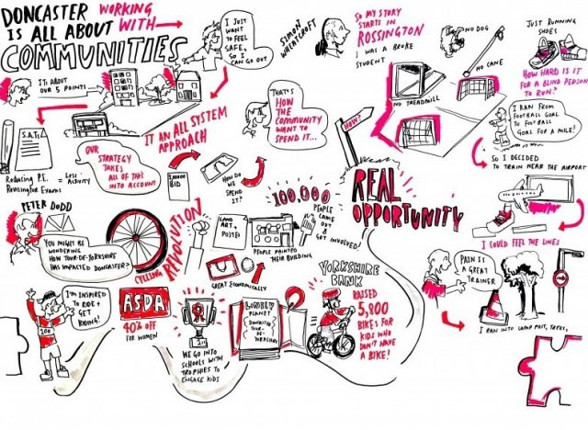

SECTION 3

Tackling Inequalities in Action - Future Parks Programme

Listening to Residents

As a result of borough-wide listening programmes such as Doncaster Talks, the GDM team knows that parks and open spaces are extremely important to residents – and a key part of GDM’s work to reduce physical inactivity rates.
Findings of a Resident Panel survey on residents' views on Doncaster's parks and open spaces (July 2021) reinforced this and add more detailed insights. In summary:
- Residents recognise the value of parks and open spaces, and appreciate them more now than they did prior to COVID-19. But they feel others do not value them and they are not as well looked after as they were in the past.
- Half of residents have increased the frequency of their visits to parks and open spaces compared with before COVID-19. Whilst active community residents still use parks and open spaces less frequently than non-active community residents, they are more likely to have increased the frequency of their visits since the outbreak of the pandemic, and the average length of their visits is longer.
- Most residents are aware of parks and open spaces in Doncaster and agree there is a park within walking distance to their home. This is important as most residents do not want to spend much time travelling to parks and open spaces.
- Residents currently use parks and open spaces to play with children/go on a family outing, or to undertake outdoor physical activity or sport. However, they agree that parks and open spaces need to be about more than physical activity and playing, and agree that they would use parks for various other activities if these were available.
- However, there are various barriers which prevent residents from using parks and open spaces, including others’ behaviour and safety, and residents avoiding using them at night. Residents also highlighted that they would make more use of them if they were more welcoming in appearance. There is also the perception that parks are mainly used by, and are important for, parents and/or families.

Co-producing Improvements

Through our Future Parks programme, we are unlocking the power of parks and open spaces to start conversations, bring residents together, generate interest and provide links to wider community centred approaches. Significant progress made this year:
- 1,715 residents have been engaged in shaping the development of the Future Parks programmes on four sites through surveys and community events.
- The Doncaster Green Space Network (DGSN) has supported the development of new and existing voluntary groups, increasing the capacity across the network through training and supporting groups in delivering community events and activities.
- In the autumn, we launched the Doncaster Parks Corporate Volunteering pilot, helping business deliver their social corporate responsibility while helping restore our parks and green spaces through active work.
- Using HUQ data we have identified that across the 15 future parks over 2,760,000 have visited these spaces in 2022, through the scheduled investment it will be determined if this has had an impact on parks usage.

Reality Check

This is an extract from a guest blog on the Council’s Intranet from Kelly Watson, Well Doncaster Officer, published 28th October 2022. It starkly demonstrates the barriers some residents face to be more physically active, even when on the face of it opportunities to do are cost free. It also highlights the open, candid learning culture that the GDM Team and its partners, including Sport England, see as an essential foundation for success.
As part of our role in reducing health and wealth inequalities, we partner with Get Doncaster Moving (GDM) and Sport England amongst others to share ideas and strategies and find what is out there that can help the people we meet daily.
As part of this myself and my colleague were chatting to two women who were there representing Sport England, advocating the value of using free spaces such as parks to get active. As a parent with three children, my mind instantly thought back to clothing and footwear. How many pairs of shoes do your children have? How many sets of trainers? How many coats? What if I were to tell you that as a single working parent my children have a single pair of school shoes and a pair of trainers for PE and playing out? If I were to say that my children only had one coat? That I have had to make the choice of taking my kids for a walk to keep active or keep their uniform clean so that the school does not think I am sending my kids to school scruffy? These are the hidden barriers to exercise.
It is factors like these that many parents who are experiencing poverty think about daily. They just do not say them aloud. Except, I did. I let go of the shame and explained these barriers. I explained the conversations I had been privy to where they want to give schools washing machines because the kids are not clean at school.
These comments were over and done within a passing five-minute conversation whilst I put some sugar in my tea. I did not expect them to go anywhere. I did not expect anyone to listen. Weeks passed and then that familiar ping of emails. It was an email from Jodie at GDM where she relayed the story of hidden barriers that I had passed on with my colleague Kerry. Better than that, the lady I spoke to had told the story of hidden barriers to physical activity to everyone until she reached a meeting where someone relayed it to her. It was getting all the people talking and moving looking at ways that these challenges can be overcome.
Well Doncaster believes in people like me. They see our value when we do not see it in ourselves, and they look for the compassion and empathy needed to visit the disadvantaged communities we work in. Well Doncaster knows if given the chance, communities can work together to tackle the problems they are a part of. They just need a chance. I needed that chance.
I am a product of Well Doncaster.

LTA Parks Tennis Project

Doncaster’s GDM Team is increasingly working with National Governing Bodies (NGBs) to provide opportunities for residents to be more physical active and build stronger communities.

For example, Doncaster is currently working with the LTA, the national governing body for tennis in Britain, to develop parks tennis. This this already generated a significant amount of learning into the negotiations and compromises needed to blend national and local delivery frameworks to ensure they are focussed on tackling inequalities. It also demonstrates GDM principles-driven approach to delivery in action.
Over the past decade, the LTA has received targeted investment from Sport England to make tennis relevant, accessible, welcoming and enjoyable for everyone. In October 2021, the Park Tennis Project was announced – which involves working with local authorities to invest in park tennis courts, and provide and sustain more affordable, engaging and accessible opportunities to increase participation at these facilities.
This project clearly chimes with Doncaster’s Future Parks objectives.
Pre-pandemic conversations
Initial conversations centred on the tennis courts at Wheatley Grove Park, which are open access. Wheatley Hills Tennis Club is located approximately 200 metres from the park and has always been supportive of it. The Club agreed to deep clean and repaint the courts.

The LTA supported this development with the ‘Clubspark’ online booking system, without the need for secure gate access being installed – which would normally be the LTA’s preferred approach to increase participation (see Stage 2 for more detail on this).

Initial indications are that this hybrid access model is working. Whilst online court bookings are relatively low (79 bookings in 2021 and 142 so far in 2022 as at 4 October 2022), Huq data suggests that more people are using the courts on a “turn up and play” basis. There were approximately 1,624 users during 2021 and a similar figure is expected for 2022.
LTA investment for five parks
In early 2022, the LTA approached Doncaster with the very welcome offer of investment for five parks they had identified through a desktop assessment of court condition, latent demand and IMD:
- Hexthorpe Park.
- Westfield Park.
- Grove Park.
- Elmfield Park.
- Haslam Park.
The first three are all part of Doncaster’s Future Parks programme in deprived areas. GDM’s research has identified many barriers to usage and participation, for example some residents feel unsafe or uncomfortable and also cite the lack of activities or facilities.
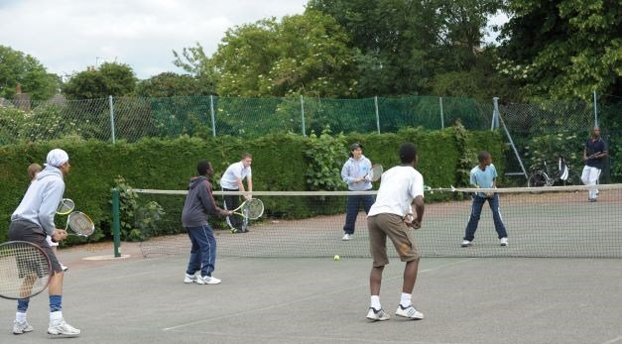
Park Courts Quality and Access – LTA Requirements
The LTA’s data identified that:
- Other than the weather, and in the past year Covid restrictions, places to play (45%) is the main barrier to taking part more often.
- 19% of park players say that they don’t play more due to poor quality courts.
As part of their investment, the LTA identified a number of requirements for discussion:
- All venues connected to on line booking for courts and activities:
- With a mobile-first approach (using an app) for Lower Socio-Economic Groups that are more likely to access the internet via a smartphone.
- Gate access systems to drive participation in the more populated areas:
- With LTA evidence showing that open, unmanaged and free courts can present barriers for people. Gate access systems also ensure the capture of all participation data that will be an important aspect of showing a return for the investment.
- Free offer to engage communities.
- Recreational competitive offer.
- Established operating model – courts and activities.
- Sustainability plan in place.
The first two requirements were a particular cause for debate from the standpoint of inclusivity, reducing inequalities and Doncaster’s focus on supporting inactive residents.
The GDM team recognised that the LTA have had considerable success elsewhere (e.g. in Manchester and Sheffield) in increasing the overall numbers playing tennis and had ambitious targets to do more. Doncaster’s focus on the inactive meant that the GDM Team wanted to work at an in-depth level with the most inactive people in these communities, giving them the skills and confidence to access the app and use it to book a court, without the presence of the access gate initially.
In addition, with the objective of achieving an overall net increase in physical activity rates in mind, Doncaster wanted to mitigate the risk of displacement (from one physical activity to another).
The COM-B model informed Doncaster’s discussions with the LTA. Whilst ‘Capability’ and ‘Motivation’ may already be well developed for those looking for a place to play (i.e. it is just ‘Opportunity’ that is required), currently inactive residents need a greater level of support to strengthen all three factors, particularly those living in the most deprived areas.
Reaching a compromise
The GDM team and the LTA acknowledged that they each had legitimate perspectives and objectives – but were targeting different populations (albeit with a degree of overlap) and using different metrics to report back on.
With support from Sport England, a hybrid approach was negotiated that would work in parks and it was agreed that the investment will come into Doncaster and we will link it to the Future Parks Programme.
Both parties welcomed Sport England support for developing their working relationship and overcoming barriers to progress by working as a funder alongside the GDM team (as an LDP) at a local level.
More specifically, it was agreed that:
- The LTA will invest in the courts that need it.
- Doncaster will run the hybrid approach (a booking system but no gate access) across all courts except Haslam Park – where we will have a booking system and gate access (but no charging policy).
  - At Haslam Park, this would be accompanied by a commitment to support those not yet ready to play tennis – particularly the inactive.
- The Council will provide the long-term maintenance of all courts – meeting both the LTA’s and GDM’s sustainability objectives.

Wrapped around this, with the support of LDP monies, GDM will supplement LTA activation with bespoke programmes of delivery that are co-designed with local residents, covering for example:
- Equipment.
- The training of tennis coach volunteers (see Stage 5).

This stage in the collaboration journey culminated in a compromise being reached on the approach to booking and accessing courts. This successfully blended Doncaster’s principles-led approach to supporting the physically inactive with the LTA’s ‘existing tennis customer-led approach’ and the associated funding criteria. Both parties were also firmly on the same page regarding the sustainability of the support for tennis.
The courts will be launched during the Spring of 2023.
LTA ‘Breaking Down Barriers’ Plan
The LTA shared a draft of their ‘Breaking Down Barriers’ Plan (for underserved, lower-socio economic groups) with the GDM Team on the 1st September 2022. It articulates the LTA’s ambition around opening tennis up to lower socio-economic groups and addressing some of the stubborn inequalities that exist within the sport.
This marked a significant step forward in consolidating the common ground between Doncaster and the LTA approach to tackling inequalities, particularly noting the Plan’s:
- Evidence base – for example the importance of intersectionality and demographic considerations when prioritising support for inactive people.
- Updated targets for parks – for example the LTA’s commitment is for 75% of the parks supported through this project to be targeted within IMDs 1-5.
- 5 Guiding Principles – including: ‘We will recognise that we don’t know everything, so we’ll listen to local communities and not ‘do to them’.

The Plan presents a huge opportunity to support further change in communities.
The LSEG Plan includes an Action Plan and the GDM team has provided the LTA with a summary of how it can contribute to the actions.

- For example, one of the LTA actions is to ‘Develop a small number of ‘hot-housed’ Community Hubs, to pilot and deliver ground-breaking participation and workforce provision, positioning tennis in way in which it’s never been done before’. The GDM team is working with a local volunteer who will be contracted by a local community enterprise (‘Flourish’, which is not a traditional sports coach delivery organisation) to train others and support the sustainability and inclusivity of the park courts.

Sustaining the Impact
GDM very much welcomes this LTA principle:

- ‘We will invest in and enable local, community leaders to be agents of their own change and create their own tennis infrastructure - we won’t parachute in traditional tennis workforce from elsewhere’.

The GDM team is purposefully small, reflecting a focus on the future sustainability of the work and of embedding skills, capacity and capability across the wider network. The provision of ‘backbone support’ is crucial to the GDM approach – with the dedicated team aligning and coordinating the work of the collective, providing a ‘helicopter view’ of the whole system and ‘joining the dots’ within it, for example to create new opportunities to support physical activity.
Supporting inactive residents to play tennis
We will continue to work with LTA local representatives and their local delivery mechanisms to reach and support residents to play parks tennis, particularly those who are currently inactive.
We will also continue to work with LTA to establish baselines for the usage of the park courts and monitoring arrangements.

Demonstrating the value of place-based working

Doncaster, the other 11 LDPs and Sport England operate with the disruptive, innovation space – challenging business as usual, harnessing positive innovation trends and developing new approaches to support physical activity. Progress may be organic, incremental, open-ended and at times hard to define. A wide variety of way of measuring success are therefore required, including:

- Case Studies/stories of impact which capture lived experiences.
- Qualitative data (e.g. surveys, focus groups).
- Quantitative data (e.g. the number more active).
- Value for Money (e.g. Return on Investment).
- Evidence of sustainable systemic change.

Doncaster will work with the LTA to ensure there is a rounded assessment of impact, reflecting the experiences of residents playing tennis in their local parks.

SECTION 4

Ten suggestions for tackling inequalities

The Get Doncaster Moving Team would like to share what they have learned from working in partnership to tackle inequalities physical activity and participation in sport.
- Start with an open and humble mind-set

- Recognise that you don’t know everything, need to listen to communities and not ‘do to them’.

- Consider if you are committed to real ‘place-based’ working

- Working in a place is not necessarily place-based working – i.e. community centred, culturally sensitive and builds on local strengths and capabilities to enable residents to see ‘people like me’ being active.
- For local impact, put the needs of communities ahead of your organisation’s objectives.

- Take an evidence led-approach… and listen to the stories and perspectives of place

- Trust the local stories you hear and be inquisitive and understand why things are the way they are.
- Build on-going evaluation and learning into the project/intervention, drawing on a wide variety of way of measuring success – from hard data to local stories.
- Be careful with data - averages may mask considerable local variations in physical activity rates.

- Be clear on what you may mean by ‘For All’

- The focus on inclusivity, reducing inequalities and supporting those most in need are increasingly the focus on place-based working – but definitions of ‘for all’ may not be the same.

- Identify areas of common ground and potential sticking points

- Recognise the starting point, perspectives and constraints of collaborating partners (which may be set by other ‘paymasters’).
- Share your principles, requirements and priorities early on in the collaboration.

- Be flexible with funding criteria and delivery requirements

- A collaborative, ‘shoulder to shoulder’ relationship between funder and delivery partner.
- Avoid inflexible ‘drag and drop’ delivery approaches – instead be open to lowering organisational boundaries and modifying funding and delivery requirements.
- Delivery that is driven by outcomes and learning and timescales that are proportionate and realistic.
- Draw upon the leadership, advice and brokerage skills of Sport England to help reach compromises.

- Focus on sustainability from the outset

- Invest in and enable local, community leaders to be agents of their own change.
- Don’t try and take short cuts - it takes time to build credibility, confidence and trust amongst the residents and to design and deliver the investment required across the system.

- Recognise the whole system factors that affect people’s motivations and capabilities

- Recognise the barriers that inactive people may face (e.g. housing and income levels) and where possible work in partnership to address them. However, be realistic about your sphere of influence.
- The COM-B model prioritises capability, opportunity and motivation as factors for changing behaviour.

- Test and Learn

- Be creative in developing new delivery approaches and be prepared to take risks.

- Keep going!

- Progress may be organic, incremental, open-ended and at times hard to define.
- Many of the challenges to be overcome will be long-standing and deeply entrenched, which make the potential impacts for people, communities and organisations even more worth the effort.

SECTION 5

Our Asks – To help tackle inequalities in physical activity

GDM’s priorities are already well represented within Doncaster’s strategic priorities, including the ‘Great 8’ delivery priorities of the new borough strategy, ‘Doncaster Delivering Together’.
GDM’s whole-system perspective means that the DDT’s clear focus on tackling inequalities and the prominence of the wellbeing essentials is particularly welcome, given how they affect the opportunities and motivations to be physically active. This includes inequalities relating to health, the economy, environment, housing and education.
An active population in turn is a key foundation for improving the overall wellbeing of the population, for example, it contributes significantly to educational attainment and employability and has been shown to reduce crime and anti-social behaviour. Active travel interventions also improve air quality and tackling climate change.
It is positive that the wellbeing essentials are already being considered through ‘task and finish’ groups. Building upon this our main ask is for Team Doncaster to consider if more could be done to:
- Prioritise a relentless, urgent focus on working with communities to ensure all residents have the wellbeing essentials – as a clear City Mission, to enable them to have the chance to thrive and contribute to thriving places and planet.

To support this we suggest:
- Identifying, evidencing and supporting what is working well.
- Challenging ‘business as usual’ approaches to tackling inequalities as reflected in policy and strategic and community level interventions – in the context of Doncaster deteriorating position in the IMD rankings.
- Identifying, prioritising and implementing the genuinely “bold actions” that will make the biggest difference strategically (e.g. City level infrastructure) and at a community level (e.g. multi-agency and community collaboration programmes).
- Applying a regenerative lens across to interventions.
- Testing and learning, supported by a culture that is open to risk taking and potentially failing when trying to break new ground.
- Better connecting policy to on the ground interventions programmes.
- Ensuring the data analysis and research work provides new insights to inform interventions, rather than confirm the challenges which are already well established.
- Ensure progress on the wellbeing essentials features prominently in Team Doncaster’s governance and performance management arrangements.

The cost of living crisis has made this even more of an imperative.

GDM will do all it can to support the City’s place-based, whole system work to reduce inequalities in Doncaster to enable all residents to have the chance to thrive and contribute to thriving places and a thriving planet.

doing less than 30 minutes of moderate intensity activity each week

